# 

# **Software Requirements Specification**

# **For**

# **“HarmonyHub”**

**Rohith.S-22MIS1082**

**Karthik.C.R-22MIS1005**

**Navtej.S.Nair-22MIS1122**

**M.MuraliKrishnan-22MIS1177**

**P.M.Aditya-22MIS1039**

# **TABLE OF CONTENTS**

**ABSTRACT 3**

**1. INTRODUCTION**

**1.1. Purpose 4**

**1.2. Intended Audience 5**

**1.3. Scope 5**

**1.4. Definitions, Acronyms, and Abbreviations 6**

**1.5. References 7**

**2. OVERALL DESCRIPTION**

**2.1. Product Perspective 9**

**2.2. Product Features 9**

**2.3. User Characteristics 10**

**2.4. Operating Environment 11**

**2.5. Assumptions and Dependencies 11**

**2.6. Design and Implementation Constraints 12**

**3. SYSTEM FEATURES AND REQUIREMENTS**

**3.1. Functional requirements 13**

**3.2. Software diagrams 15**

**3.3. External interface requirements 17**

**3.4. Database requirements 23**

**3.5 Non-Functional Requirements 23**

**ABSTRACT**

In response to the escalating mental health concerns among VIT college students, particularly within the dynamic environment of academic pursuits, 'HarmonyHub' emerges as a comprehensive web application tailored to prioritize and enhance mental health and wellness. This research paper delves into the conceptualization, implementation, and evaluative aspects of HarmonyHub, with a distinct emphasis on providing vital information, expert guidance, and specialized support for students navigating the challenges of academic life. The study explores the impact of HarmonyHub on mental health awareness, positive coping strategies, and the creation of a supportive virtual environment for students. With a focus on diverse features including user authentication, content management, real-time interaction, and privacy controls, HarmonyHub represents an innovative solution poised to positively impact the mental health landscape for VIT college students. The findings aim to inform future developments in technology-driven solutions, providing valuable insights for the broader discourse on student mental health and well-being.

**1.Introduction**

In the dynamic ecosystem of higher education, the mental well-being of students is a critical facet often overshadowed by the pursuit of academic excellence. 'VIT Well Connect' stands at the intersection of technology and mental health, aspiring to revolutionize the way VIT college students navigate the complexities of their collegiate journey. This introduction provides a glimpse into the genesis and objectives of VIT Well Connect; an innovative web application meticulously crafted to address mental health concerns. By amalgamating essential features such as information dissemination, expert guidance, and specialized support, VIT Well Connect seeks to cultivate a virtual sanctuary fostering mental wellness. This research embarks on a journey to scrutinize the profound impact of VIT Well Connect on mental health awareness, positive coping mechanisms, and the establishment of a robust support network. As the academic landscape evolves, VIT Well Connect signifies a change in basic assumptions, offering a comprehensive solution to fortify the mental health infrastructure for VIT college students.

* 1. **Purpose**

* The primary purpose of the "HarmonyHub" project is to address the escalating mental health concerns among VIT college students within the challenging context of academic pursuits.
* The project aims to prioritize and enhance mental health and wellness among students by providing vital information, expert guidance, and specialized support tailored to their needs.
* Through the implementation of essential features such as user authentication, mental health resources display, anonymous interaction options, appointment scheduling, real-time messaging with professionals, and privacy and security measures, HarmonyHub seeks to create a comprehensive solution for student mental health.
* Additional add-ons including a well-being tracker and event/workshop integration further enhance the project's capabilities in promoting mental wellness and awareness.
* The overarching goal is to create a dynamic and supportive virtual environment that fosters mental wellness, dismantles barriers to accessing support services, promotes awareness, and prioritizes the mental well-being of VIT students.

The project aims to revolutionize the way students perceive and manage their mental health within the collegiate ecosystem, contributing to a healthier and more resilient student body.

**1.2 Intended Audience**

* The "HarmonyHub" project is designed for VIT college students facing escalating mental health concerns in the demanding environment of academic pursuits.
* It caters to students who are seeking access to vital information, expert guidance, and specialized support tailored to their mental health and wellness needs.
* The project is intended for students who may benefit from features such as user authentication, mental health resources display, anonymous interaction options, appointment scheduling, real-time messaging with professionals, and privacy and security measures.
* Additionally, students interested in utilizing add-ons like a well-being tracker and event/workshop integration to further enhance their mental wellness journey are also part of the intended audience.
* While first developed for VIT college students, the adaptable nature of the "HarmonyHub" project allows for its potential adoption by other colleges and ecosystems. This flexibility opens doors for broader implementation, benefiting students across diverse educational institutions and environments.

**1.3. Scope**

The scope of the "HarmonyHub" project encompasses the development and implementation of a comprehensive web application tailored to prioritize and enhance the mental health and wellness of VIT college students. The project includes thefollowing key components:  
   
1. Feature Development: Designing and implementing essential features such as user authentication, mental health resources display, anonymous interaction options, appointment scheduling, real-time messaging with professionals, and privacy and security measures.  
   
2. Add-On Integration: Incorporating additional features like a well-being tracker and event/workshop integration to enhance the user experience and provide comprehensive support for mental wellness management.  
   
3. User Interface Design: Creating an intuitive and user-friendly interface to ensure ease of navigation and accessibility for students accessing mental health resources and support services.  
   
4. Testing and Quality Assurance: Conducting rigorous testing procedures to ensure the functionality, reliability, and security of the web application, addressing any potential issues or vulnerabilities.  
   
5. Documentation and Training*: Providing thorough documentation of the application's features, functionalities, and usage guidelines. Additionally, offering training sessions or resources to familiarize users with the platform and its capabilities.  
   
6. Scalability and Adaptability: Designing the application with scalability and adaptability in mind, allowing for potential future expansions, updates, and adaptations to suit the needs of other colleges or ecosystems beyond VIT.  
   
The scope of the project is focused on addressing the mental health concerns specific to VIT college students, while also considering the potential for broader implementation and adaptation to benefit students in diverse educational institutions and environments.

**1.4. Definitions, Acronyms, and Abbreviations**

**contract**: A legally binding document agreed upon by the stakeholders involved in the development and deployment of the "HarmonyHub" project. This includes the technical specifications, organizational responsibilities, cost considerations, and scheduling requirements.  
 **customer**: Refers to the stakeholders who initiated and funded the development of the "HarmonyHub" project. Typically, this includes administrative bodies or departments within VIT college responsible for student welfare and support services.  
 **language**: In the context of the "HarmonyHub" project, language refers to the programming languages and technologies used to develop the web application, including HTML, CSS, JavaScript, and any other relevant frameworks or libraries.  
 **partitioning**: The process of breaking down the overall project into smaller, manageable components or modules. This involves decomposing complex functionalities into smaller tasks to facilitate development and maintenance.  
 **supplier**: The individuals or teams responsible for developing and implementing the "HarmonyHub" project. This may include software developers, designers, project managers, and other relevant personnel involved in the project's execution.  
 **user**: Refers to the VIT college students who will interact directly with the "HarmonyHub" web application to access mental health resources, schedule appointments, engage in real-time messaging with professionals, and utilize other features aimed at enhancing their mental well-being.

**HarmonyHub**: The name of the web application project aimed at enhancing the mental health and wellness of VIT college students.  
 **SRS**: Software Requirements Specification - A document that describes the software product to be developed, including functional and non-functional requirements.  
 **VIT**: Vellore Institute of Technology - A prestigious educational institution located in Vellore, India.  
 **HTML**: Hypertext Markup Language - The standard markup language for creating web pages and web applications.  
 **CSS**: Cascading Style Sheets - A style sheet language used for describing the presentation of a document written in HTML.  
 **JavaScript**: A programming language commonly used to create interactive effects within web browsers.  
 **UI**: User Interface - The visual elements and interactive components of a software application through which users interact.  
 **UX**: User Experience - The overall experience of a user when interacting with a product, including usability, accessibility, and satisfaction.  
 **API**: Application Programming Interface - A set of rules and protocols for building and interacting with software applications.  
 **QA**: Quality Assurance - The process of ensuring that a software product meets specified requirements and quality standards.  
 **SSL**: Secure Sockets Layer - A security protocol that establishes an encrypted link between a web server and a browser.  
 **HIPAA**: Health Insurance Portability and Accountability Act - A U.S. legislation that ensures the security and privacy of health information.  
 **GDPR**: General Data Protection Regulation - A European Union regulation that governs data protection and privacy for individuals within the EU and the European Economic Area.  
 **API**: Application Programming Interface - A set of rules and protocols for building and interacting with software applications.  
 **FAQ**: Frequently Asked Questions - A document containing answers to common queries about a particular topic or product.  
 **CSV**: Comma-Separated Values - A file format used to store tabular data, with each record separated by a comma.  
 **SQL**: Structured Query Language - A programming language used for managing and manipulating relational databases.  
 **HTTPS**: Hypertext Transfer Protocol Secure - An extension of HTTP that provides secure communication over a computer network.  
 **LDAP**: Lightweight Directory Access Protocol - An open, vendor-neutral protocol used to access and manage directory information services.  
 **OCR**: Optical Character Recognition - The conversion of images of typed, handwritten, or printed text into machine-encoded text.

**1.5. References**

1. A. Danowitz and K. Beddoes, "Mental Health in Engineering Education: Identifying Population and Intersectional Variation," in IEEE Transactions on Education, vol. 65, no. 3, pp. 257-266, Aug. 2022, Doi: 10.1109/TE.2022.3182626.

2. R. Bowman, O. Cooney, A. Thieme, B. R. Cowan, and G. Doherty, "Pervasive Therapy: Designing Conversation-Based Interfaces for Ecological Momentary Intervention," in IEEE Pervasive Computing, vol. 21, no. 4, pp. 55-63, 1 Oct.-Dec. 2022, Doi: 10.1109/MPRV.2022.3209068.

3. Worsley, J., Pennington, A., & Corcoran, R., "What interventions improve college and university students’ mental health and wellbeing? A review of review- level evidence.", July 29, 2022, <https://doi.org/10.1371/journal.pone.0266725>

4. Shrivastava, A., & Rajan, D. (December 2023). "Assessment of Depression, Anxiety and Stress among Students Preparing for Various Competitive Exams." DOI: 10.13140/RG.2.2.10711.42406.

5. Brankovich, R., & Loebach, J. (2022, June 16). "Self-Care and Mental Health Among College Students During the COVID-19 Pandemic: Social and Physical Environment Features of Interactions Which Impact Meaningfulness and Mitigate Loneliness." Frontiers in Psychology, 13, 879408. Doi: 10.3389/fpsyg.2022.879408.

6. Brogley, C. (2022). "Observations of Positive Mental Health Indicators in Undergraduates Using Specialized Mobile Apps During the COVID-19 Pandemic." ProQuest Dissertations Publishing, The University of Western Ontario, Canada. (Accession No. 29951691).

7. Asghar, Muhammad, Angela Minichiello, and Shaf Ahmed. "Mental health and wellbeing of undergraduate students in engineering: A systematic literature review." *Journal of Engineering Education* (2023).

8. Shea, Munyi, et al. "College students’ barriers to seeking mental health counseling: Scale development and psychometric evaluation." Journal of counseling psychology 66.5 (2019): 626.

9. N. Zhang, Q. Deng, and T. Guan, "Development and Realization of the Psychological Counseling Platform for Colleges in the Cloud Environment," 2022 6th International Conference on Computing Methodologies and Communication (ICCMC), Erode, India, 2022, pp. 38-41, Doi: 10.1109/ICCMC53470.2022.9753954. keywords: {Employee welfare; Psychology; Clustering algorithms; Mental health; Data mining; Task analysis; Expert systems; Psychological Counseling; Platform Design; Cloud Environment; Cloud computing},

**2. Overall Description**

**2.1 Product Perspective**

The "HarmonyHub" web application operates within the ecosystem of mental health support services offered by VIT Chennai. It serves as a centralized platform designed to prioritize and enhance the mental health and wellness of VIT Chennai students.  
   
From a technical standpoint, the application is a standalone system that interacts with existing university databases, such as student records and appointment schedules at VIT Chennai. It integrates seamlessly with other institutional systems to ensure accurate and up-to-date information.  
   
The "HarmonyHub" project is developed using modern web technologies such as HTML, CSS, JavaScript, and potentially other frameworks or libraries to ensure a user-friendly and responsive interface across various devices and browsers.  
   
Additionally, the application adheres to industry-standard security protocols to safeguard sensitive user data and ensure compliance with privacy regulations such as GDPR and HIPAA.  
   
The "HarmonyHub" web application is designed with scalability in mind, allowing for future expansions and updates to accommodate the evolving needs of VIT Chennai students. It can also be adapted for use in other college settings or integrated with third-party platforms to further extend its functionality and reach.  
   
Overall, the "HarmonyHub" project represents a comprehensive and innovative solution within the context of VIT Chennai, providing students with convenient access to mental health resources, support services, and a supportive virtual environment tailored to their needs.

**2.2 Product Features**

**User Authentication: Secure** and user-friendly login/logout system for personalized access and data security.  
 **Mental Health Resources Display: Easy** access to diverse mental health resources and information, fostering awareness and support.  
 **Anonymous Interaction Option: Option** for students to connect with the VIT counseling center anonymously, promoting inclusivity and addressing potential barriers to seeking help.  
 **Appointment Scheduling: Streamlined** system for students to schedule appointments with the counseling center, ensuring efficient access to support services.  
 **Real-time Messaging with Professionals: Enable** real-time communication between students and mental health professionals through a secure and responsive messaging system.  
 **Privacy and Security Measures: Prioritize** user privacy through robust security measures, including encryption protocols, to create a confidential and safe virtual environment.

Additional Add-Ons:  
   
**Well-being Tracker: Feature** for students to track their well-being over time, providing insights and encouraging proactive mental health management.  
 **Event and Workshop Integration: Calendar** integration for mental health-related events and workshops, promoting community engagement and knowledge-sharing.  
 These features collectively provide a comprehensive solution to address the mental health concerns of VIT Chennai students, fostering a supportive environment and facilitating access to essential support services and resources.

**2.3 User Characteristics**

**VIT Chennai Students: Main** users of the "HarmonyHub" web application.  
 Varied demographics including undergraduate, postgraduate, and research students.  
 Prioritize convenience and accessibility in accessing mental health resources.  
 Seek confidential and supportive environments for discussing mental health concerns.

**Prerequisites**: Access to internet-enabled devices such as smartphones, laptops, or computers. Basic familiarity with web browsing and application usage.  
**Administrative Staff: Manage** the backend of the application including user accounts, appointment scheduling, and content management.  
Ensure smooth operation and integration of the application with existing university systems.

**Prerequisites**: Administrative access to university databases and systems. Knowledge of user account management and basic technical proficiency for system administration tasks.  
**Mental Health Professionals: Provide** support and guidance to students through the application's messaging system.  
Require secure and confidential communication channels to interact with students effectively.

**Prerequisites**: Professional qualifications and credentials in mental health counseling or related fields. Training on how to use the application's messaging system securely and effectively.  
**Faculty Members: Play** a supportive role in promoting mental health awareness among students.  
Encourage students to utilize the resources and services provided by the application.

**Prerequisites**: Familiarity with the "HarmonyHub" application and its features. Awareness of mental health issues prevalent among students and the importance of promoting mental health awareness.  
**Parents/Guardians: Concerned** about the well-being of their children studying at VIT Chennai.  
May access the application to stay informed about available mental health resources and support services for their children.

**Prerequisites**: Access to the internet and a compatible device. Familiarity with the application's features and functionalities. Understanding of their role in supporting their children's mental health and well-being during their academic journey at VIT Chennai.

Understanding these user characteristics is essential for designing a user-friendly and effective "HarmonyHub" application that meets the diverse needs and preferences of its users at VIT Chennai.

**2.4 Operating Environment**

**Cross-Platform Compatibility**: "HarmonyHub" seamlessly functions across different web browsers and operating systems, ensuring accessibility for all users regardless of their device preferences.  
 **Internet Accessibility**: With only the requirement of stable internet connectivity, users can readily access mental health resources and support services through the application.  
 **Device Flexibility**: Whether on desktops, laptops, tablets, or smartphones, the application caters to users' diverse needs, providing a consistent experience across various devices.  
 **Modern Web Technologies:** Leveraging HTML, CSS, JavaScript, and other contemporary frameworks, "HarmonyHub" delivers an engaging and responsive user interface.  
 **Data Security and Compliance**: Hosted on secure servers and compliant with privacy regulations such as GDPR and HIPAA, "HarmonyHub" prioritizes the protection of user data and confidentiality.

**2.5 Assumptions and Dependencies**

**General**

**Assumptions:**  
   
Users have access to internet-enabled devices and basic internet connectivity.  
 VIT Chennai has existing infrastructure to support the hosting and maintenance of the "HarmonyHub" web application.  
 Users are willing to engage with the application and utilize its features for mental health support and wellness.

**Dependencies:**  
   
Availability of necessary hardware and software resources for development and deployment.  
 Integration with existing university systems for user authentication, appointment scheduling, and data management.  
 Compliance with regulatory requirements such as GDPR and HIPAA for data privacy and security.  
 Collaboration and support from relevant stakeholders including administrative staff, mental health professionals, and faculty members for successful implementation and adoption of the application.  
 Adequate training and support for users and administrators to effectively utilize and manage the application.

**Technical**

**Web Technologie**s: "HarmonyHub" relies on fundamental web technologies such as HTML, CSS, and JavaScript to deliver its user interface and functionality.  
 **Frameworks and Libraries:** It may utilize additional frameworks and libraries, such as React.js or AngularJS, to enhance interactivity and streamline development.  
 **Server Environment:** The application depends on a robust server infrastructure, including backend technologies like Node.js or Django, to handle user requests, process data, and ensure system reliability.  
 **Database Management System (DBMS):** Integration with a DBMS like MySQL, PostgreSQL, or MongoDB is essential for storing and managing user data, appointment schedules, and other relevant information.  
 **External APIs:** "HarmonyHub" may integrate with external APIs for features like real-time messaging, event notifications, or data analytics, enhancing its functionality and user experience.

**2.6 Design and Implementation Constraints**

**Compatibility**: "HarmonyHub" must ensure compatibility with a wide range of devices, screen sizes, and web browsers to accommodate diverse user preferences and ensure a consistent user experience.  
 **Performance**: Design and implementation must prioritize efficiency and responsiveness to minimize load times and ensure smooth navigation, particularly for users with slower internet connections or older devices.  
 **Security**: Stringent security measures must be implemented to safeguard user data, protect against unauthorized access, and ensure compliance with privacy regulations such as GDPR and HIPAA.  
 **Scalability**: The design should be scalable to accommodate potential growth in user base and feature expansion over time without compromising performance or usability.  
 **Resource Limitations**: The project may face constraints in terms of budget, time, and available human resources, requiring careful prioritization and efficient use of resources throughout the design and implementation process.

**3. SYSTEM FEATURES AND REQUIREMENTS**

**3.1. FUNCTIONAL REQUIREMENTS**

|  |  |
| --- | --- |
| MODULES | FUNCTIONAL REQUIREMENTS |
| 1. Login Page | * users can enter their username and password * users will be redirected to the home page after the credentials are verified |
| 2. Appointment scheduling | * students should be able to create accounts based on university email address. * user authentication should have methods like email-verification and two factor authentication * it should include the remainder such as date, time, location, and counselor name |
| 3. Anonymous Interaction Option: | * helps the user connect with the counseling center * helps the user to hide his/her name, if needed * helps the user to access the different support services provided by the counselling center |
| 4. Mental health resources display: | * helps the user access materials like online resourses, and websites that provide the user with reliable and evidence-based information about mental health topics. |
| 5. Real Time Messaging Feature with Professionals | * implement end-to-end encrypted messages to make sure that there is secure communication between users * it should comply with relevant privacy conditions * allow users to use images, and files for sharing relevant information * this feature should provide search and messaging history reviewing past interactions and maintain continuity in discussions |
| 6.Well-Begin Tracker | * provide a selection of metrics regarding well-begin metrics including stress-levels, academic workload * providing visual representations of their well-begin data, including graphs, charts and trend analysis * allow users to set their personalized well-being goals based on their desired outcomes and area of improvement. |
| 7. Event and Workshop Integration | * Facilitate Collaboration with student or organization clubs and campus groups by allowing them to submit and co-mental health related activities. * Display events and workshops so that it can be easy for the users to enroll in them for their betterment. * Allow users to register for events and events directly through the calendar interface. |

**3.2. SOFTWARE DIAGRAMS**

**3.2.1 UNIFIED MODEL LANGUAGE DIAGRAM**

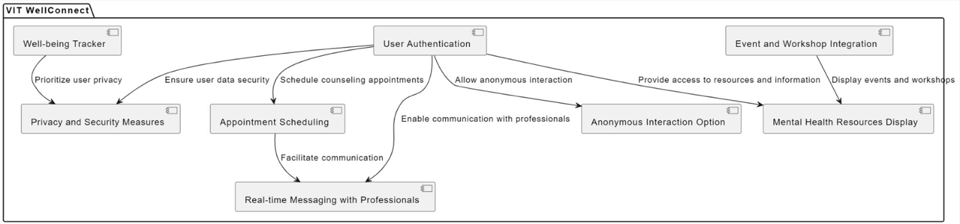

**3.2.2 USECASE DIAGRAM AND ER DIAGRAM**

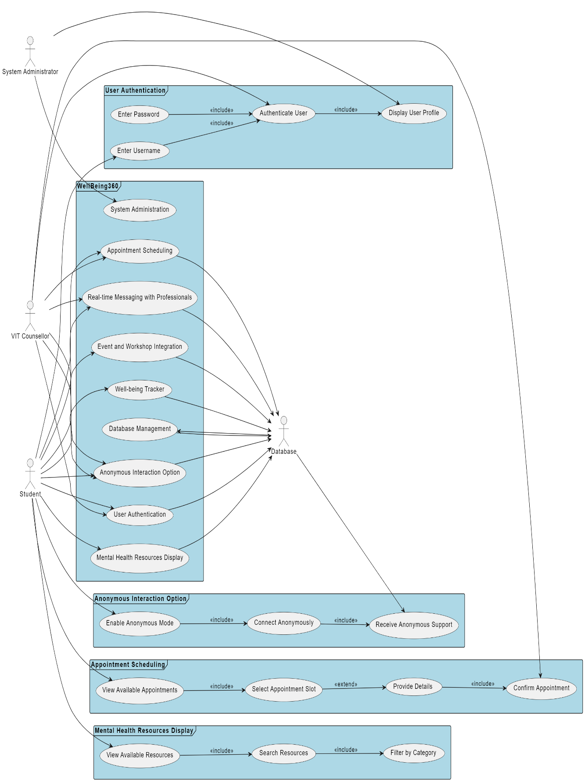

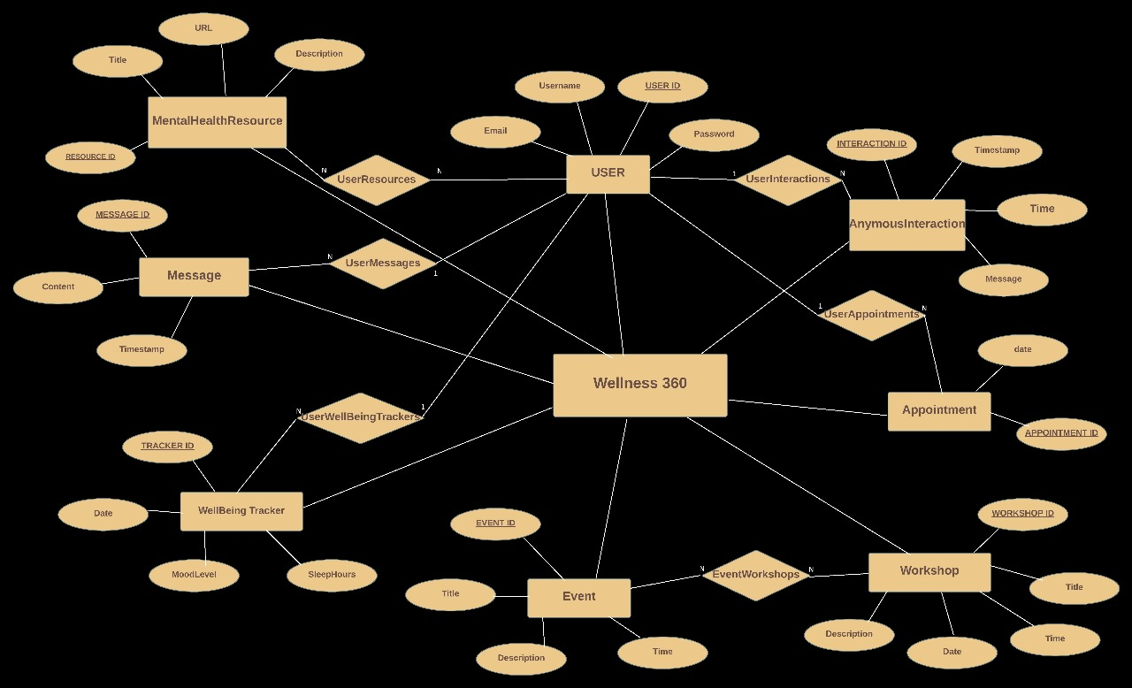3.2.3 ENTITY-RELATIONSHIP DIAGRAM

**3.3. EXTERNAL INTERFACE REQUIREMENTS**

**3.3.1. USER INTERFACE:**  
 The user interface is the interface between the platform and the end users, such as the students, counselors, and administrators. The requirements of the user interface are:

* This interface helps the user to get access to all the functionality that is provided by the platform.
* The user interface should provide clear and concise instructions, feedback, and error messages wherever necessary in simple and respectful language.

The user interface (UI) of the "HarmonyHub" web application is designed to provide a seamless and intuitive experience for VIT Chennai students seeking mental health resources and support services. Key components of the UI include:

* **Homepage**:
  + Upon logging in, users are greeted with a visually appealing homepage featuring essential information and navigation options.
  + The homepage may include personalized greetings, announcements, and quick access links to commonly used features.
* **Navigation Menu**:
  + A user-friendly navigation menu is prominently displayed, allowing users to access different sections of the application easily.
  + Menu options may include "Dashboard," "Appointments," "Resources," "Messaging," "Settings," and "Logout."
* **Dashboard**:
  + The dashboard provides an overview of the user's upcoming appointments, recent messages, and other relevant information.
  + Users can customize their dashboard layout and preferences based on their individual needs and preferences.
* **Appointment Scheduling**:
  + A dedicated section allows users to schedule appointments with mental health professionals conveniently.
  + Users can view available appointment slots, select preferred times, and receive confirmation notifications upon booking.
* **Resources Library**:
  + The resources library offers a comprehensive collection of mental health resources, including articles, videos, self-help guides, and external links.
  + Resources are categorized and searchable, allowing users to easily find information relevant to their needs.
* **Real-time Messaging**:
  + A secure messaging interface enables users to communicate directly with mental health professionals in real-time.
  + Users can initiate new conversations, view message history, and receive timely responses from professionals.
* **Settings**:
  + The settings section allows users to customize their profile, notification preferences, and other account settings.
  + Users can update their personal information, change passwords, and manage privacy settings.
* **Accessibility Features**:
  + The UI incorporates accessibility features such as text resizing, contrast adjustments, and keyboard navigation to ensure inclusivity for users with disabilities.
  + Screen reader support and alternative text for images are also implemented to enhance accessibility.

The user interface of "HarmonyHub" prioritizes simplicity, functionality, and accessibility, aiming to provide a positive and empowering experience for VIT Chennai students seeking support for their mental health and wellness journey.

**Few Examples:**

**User Authentication**

**SIGN-IN**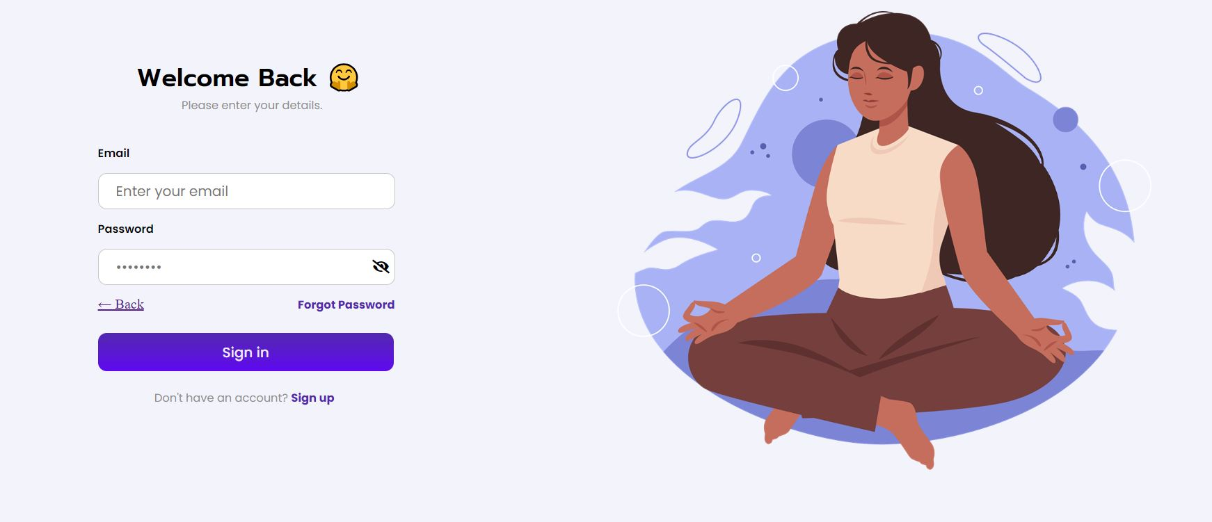

**SIGN-UP**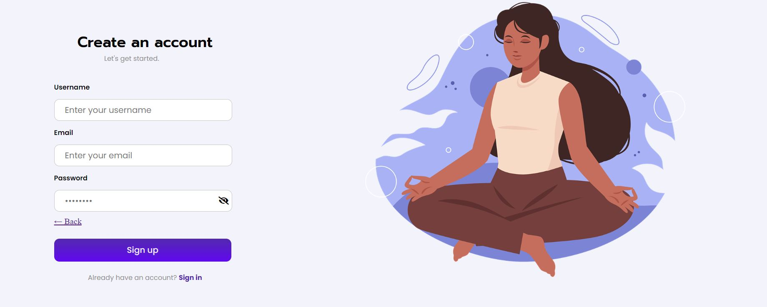

**CONTACT US AND FEEDBACK**

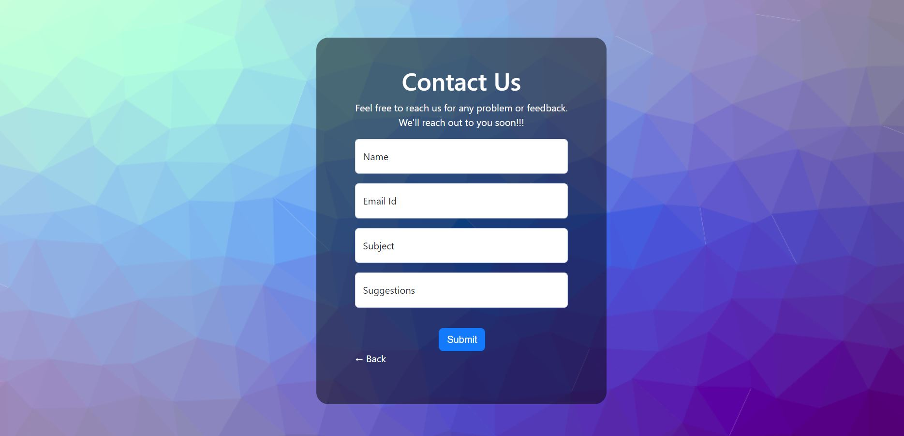

**3.3.2. COMMUNICATION INTERFACE**

This is the interface between the platform and the communication channels used to connect the users with other users. The requirements that are needed for this interface are:

* The communication interface will use appropriate channels to connect the users using the platform.
* The interface should protect the privacy of the users
* The interface design should be simple, and it should provide the users with clarity about the platform.

The "HarmonyHub" web application provides a robust communication interface that facilitates seamless interaction between VIT Chennai students and mental health professionals. Key features of the communication interface include:

* **Real-Time Messaging**:
  + Users can engage in real-time text-based messaging with mental health professionals directly within the application.
  + Messages are delivered instantly, allowing for timely communication and support.
* **Secure and Confidential**:
  + The messaging interface is encrypted using industry-standard security protocols (such as SSL/TLS) to ensure the confidentiality and privacy of user communications.
  + End-to-end encryption protects messages from unauthorized access or interception.
* **User-Friendly Interface**:
  + The messaging interface is designed to be intuitive and user-friendly, with familiar messaging conventions such as message threading, typing indicators, and read receipts.
  + Users can easily navigate through conversations, view message history, and access additional features such as file attachments and emoji support.
* **Notification System**:
  + Users receive notifications for new messages, appointment reminders, and other relevant updates via email or in-app notifications.
  + Notification preferences can be customized based on user preferences, ensuring timely communication without being intrusive.
* **Multimedia Support**:
  + The messaging interface supports multimedia content such as images, videos, and documents, allowing users to share relevant information and resources during conversations.
  + Multimedia files are securely transmitted and stored within the application, ensuring privacy and data security.
* **Offline Messaging**:
  + In the event of connectivity issues, users can still send messages offline, which will be queued and delivered once the connection is restored.
  + Offline messages are stored securely and encrypted to maintain confidentiality.
* **Accessibility Features**:
  + The messaging interface incorporates accessibility features like screen reader support and keyboard navigation to ensure inclusivity for users with disabilities.
  + Alternative text for images and clear labeling of interactive elements enhances usability for all users.

Overall, the communication interface of "HarmonyHub" aims to provide a safe, secure, and user-friendly platform for VIT Chennai students to connect with mental health professionals, seek support, and engage in meaningful conversations about their mental health and well-being.

**3.3.3. SOFTWARE INTERFACE**

The software interface is the interface between the platform and all the other software systems that the platform uses or provides. The requirements for this interface are:

* The software interface should support modularity, reusability, and extensibility and it should also allow for easy integration between the modules and enhancements of the platform features and functions.
* The software interface should use the standard and documented formats, protocols, and methods such as REST, SOAP etc... to exchange data between different modules of the platform.

The "HarmonyHub" web application seamlessly integrates with various software components and systems to deliver its functionality and services. Key aspects of the software interface include:

* **User Authentication System**:
  + Integrates with VIT Chennai's existing user authentication system or Single Sign-On (SSO) solution to verify user identities securely.
  + Enables users to log in to the application using their university credentials or other authorized authentication methods.
* **Database Management System (DBMS)**:
  + Interfaces with a robust DBMS such as MySQL, PostgreSQL, or MongoDB to store and manage user data, appointment schedules, resource content, and other application-related information.
  + Utilizes structured query language (SQL) or NoSQL queries to retrieve and manipulate data efficiently.
* **External APIs**:
  + Interfaces with external APIs to access additional functionality or services, such as real-time messaging platforms, calendar integrations, or data analytics services.
  + Implements API endpoints to send and receive data securely between the application and external systems.
* **Messaging Protocols**:
  + Supports messaging protocols such as WebSocket or HTTP/2 for real-time communication between users and mental health professionals.
  + Ensures efficient and reliable message delivery while maintaining security and privacy standards.
* **Notification Services**:
  + Interfaces with notification services such as email or SMS gateways to send notifications and alerts to users about new messages, appointment reminders, and other important updates.
  + Utilizes APIs or standardized protocols (e.g., SMTP for email) to trigger and deliver notifications effectively.
* **Web Technologies**:
  + Utilizes modern web technologies including HTML, CSS, JavaScript, and potentially frontend frameworks such as React.js or AngularJS to create the user interface and deliver a rich user experience.
  + Adheres to web standards and best practices for cross-browser compatibility and performance optimization.
* **Security Components**:
  + Interfaces with security components such as SSL/TLS certificates, firewalls, and intrusion detection systems to ensure data encryption, secure transmission, and protection against cyber threats.
  + Implements secure coding practices and authentication mechanisms to prevent unauthorized access and maintain data integrity.
* **Administrative Tools**:
  + Provides administrative interfaces or tools for managing user accounts, content moderation, system configuration, and other administrative tasks.
  + Ensures role-based access control (RBAC) to restrict administrative privileges and maintain system security.

By seamlessly interfacing with these software components and systems, the "HarmonyHub" application delivers a comprehensive and integrated solution for supporting the mental health and well-being of VIT Chennai students.

**3.4. DATABASE REQUIREMENTS**

**RDBMS**: Utilize a robust RDBMS like MySQL or PostgreSQL for efficient data storage.  
**Schema Design:** Create a structured database schema covering user data, appointments, resources, and messaging.  
**User Data:** Securely store user profiles, authentication credentials, and preferences.  
Appointment Scheduling: Maintain records for appointments, including date, time, and user IDs.  
**Resource Content:** Store mental health resources with metadata and content storage fields.  
**Messaging System:** Implement tables for secure messaging between users.  
**Audit Trail:** Track database transactions and user activities for accountability.  
**Backup and Recovery:** Regularly backup the database and implement recovery procedures.  
**Scalability and Performance:** Design for scalability and optimize database performance.  
**Data Security:** Implement encryption, access controls, and secure coding practices to protect sensitive data.

**3.5 Non-Functional Requirements**

Non-Functional Requirements for the "HarmonyHub" Project:

* **Performance**:
  + The application must load within 3 seconds on average, even under peak usage conditions, to ensure a responsive user experience.
  + Response times for user interactions such as appointment scheduling and real-time messaging should be less than 1 second to maintain user engagement.
* **Reliability**:
  + The application should have an uptime of at least 99.9%, with scheduled maintenance and downtime communicated to users in advance.
  + Data integrity and consistency must always be maintained, with backups and recovery mechanisms in place to prevent data loss.
* **Security**:
  + User data must be encrypted during transmission using SSL/TLS protocols to prevent unauthorized access or interception.
  + Access to sensitive information such as appointment details and user profiles should be restricted based on user roles and permissions.
  + The application must adhere to industry-standard security practices and undergo regular security audits to identify and address vulnerabilities.
* **Scalability**:
  + The system should be able to accommodate a growing user base and increased usage without degradation in performance or functionality.
  + Scalability should be achieved through horizontal scaling, allowing additional servers to be added to handle increased load as needed.
* **Usability**:
  + The user interface must be intuitive and easy to navigate, with clear labels, instructions, and error messages to assist users in completing tasks.
  + Accessibility features such as screen reader support and keyboard navigation should be implemented to ensure inclusivity for users with disabilities.
* **Compatibility**:
  + The application should be compatible with a wide range of devices, screen sizes, and web browsers to ensure a consistent user experience across platforms.
  + Compatibility testing should be conducted regularly to identify and address any compatibility issues with new browser versions or device types.
* **Maintainability**:
  + The codebase should be well-documented, modular, and adhere to coding standards to facilitate ease of maintenance and future enhancements.
  + Version control systems such as Git should be used to manage code changes and facilitate collaboration among development teams.
* **Regulatory Compliance**:
  + The application must comply with relevant data protection regulations such as GDPR and HIPAA, with mechanisms in place to obtain user consent for data processing and ensure data privacy and security.
  + Any third-party libraries or services used in the application must also comply with applicable regulations and industry standards.